INPUT PROMPT : .
"Create a comprehensive cybersecurity and safe AI usage advisory for students and corporate teams. Highlight critical daily digital hygiene habits, multi-factor authentication, phishing defenses, and password management with practical DOs and DON'Ts."

SOURCE: .
https://docs.google.com/document/d/1d_22lNMaAoJOQcKIa8iUiajF4sUVGW1DblfxJrBStYM/edit?usp=sharing

PARAMETERS: .
Professional, Tone : English , level of medium : Concise

OUTPUT GENERATED: .

https://drive.google.com/file/d/16vdwLGf0yX4OMuVY0LZbu125VP5736BR/view?usp=sharing
VIDEO :
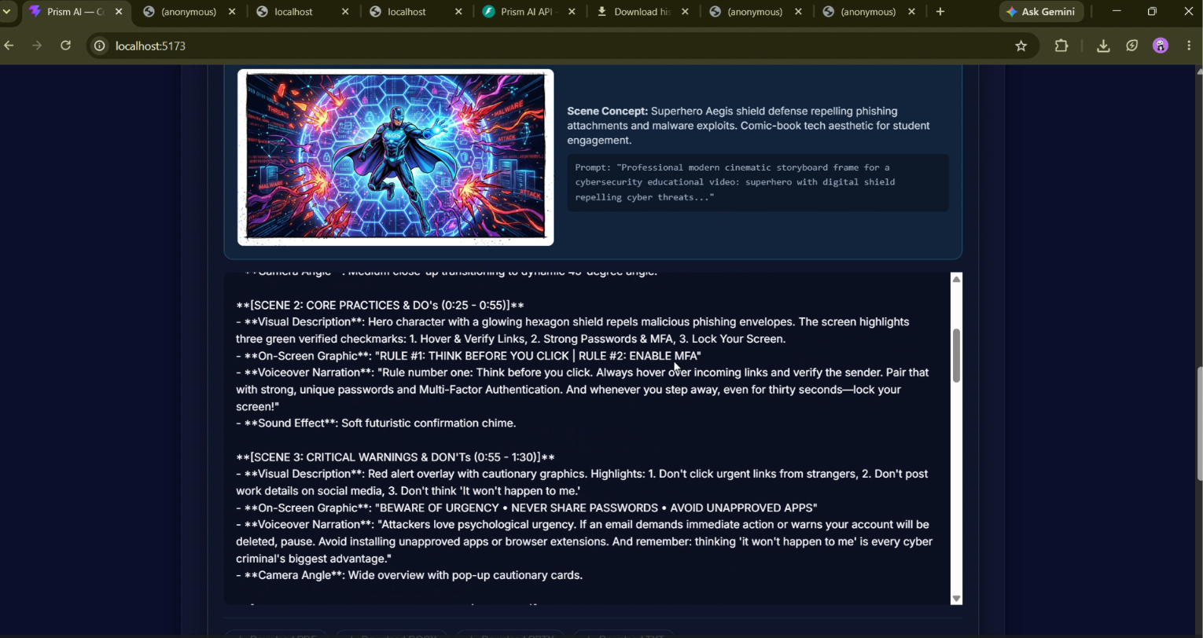

LINKED IN POST
